Good afternoon, this is Bonnie Demmons, Principal of HMMS, with messages for the week of February 17th.
Happy Family Day to all of our HMMS families. We know that families are comprised of many different combinations of people and we hope that you have had some time today to enjoy the sunshine, mild temperatures and to be with the people you consider to be “family”.
Thank you to all the families and our PSSC who contributed to Staff Appreciation Week last week at HMMS. The very thoughtful notes from families and students throughout the week, along with snacks, treats, cake, lunch on Thursday, and so much more, were all so greatly appreciated by our HMMS staff. We consider you all part of the larger HMMS family and we are very thankful for you all and the gifts you gave in recognition of the hard work of our staff to make HMMS the best.
Thank you to all HMMS families and students for selling Mitchell’s Soup Company products. The order was submitted last week and thank you to the parents who assisted with the tallying of the orders. We are expected to receive the soup packages this week, and if there are family members available to assist with the sorting, it would be greatly appreciated. If you are indeed available this week, please send me a reply and I will update you on the specifics once they have been determined by the company. Thank you once again for your support as we sold 546 packages and raised $1911 to go towards our gym improvements.
Please note that the Happenings will be sent to you all tomorrow morning once activities and events have been updated.
Congratulations to the Diamonds Cheer Team as they placed third this weekend at the NB Junior Cheerleading Association Middle School Competition. Well done girls and coaches! The middle school cheer competition season begins with MNS hosting on Saturday, March 14th. We look forward to watching the team’s routine over the course of the next few months. Exciting times ahead! #BlueBearPride
Congratulations to the Varsity Boys’ basketball team and coaches for winning 1st place in their Division for Basketball Provincial play this weekend, where they met Sussex Middle in the finals! Well done boys, and once again congratulations!
To the Varsity Girls who went to Provincials, as well as our JV Basketball teams this season, and their coaches, who worked very hard throughout the course of the basketball season, we are very proud of your determination, team work and school spirit! #BlueBearPride to all our student athletes, coaches and volunteers.
Yearbooks are on sale now for $40 at Jostens.com. You can have it personalized with your name for $5 and add unique icons for $3 each. The deadline to order your yearbook is this Friday, February 21st so order your yearbook now so you don’t miss out on this great memory. Thank you to Mr. Lowe and his team for working hard to prepare this book.
School clothing is available for sale at the link that is included below. This is a new clothing company for HMMS this school year but some of the same favorites of our students and staff. Payments are made online and all clothing items are shipped directly to the school. We hope you will like the number of options available. The deadline to place an order is Saturday February 29th.
https://hmms2020.itemorder.com/sale
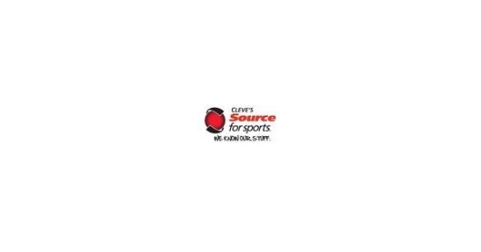 | Harry Miller Middle School Apparel 2020 Apparel 2020  Online ordering for Harry Miller Middle School Apparel 2020 Apparel 2020 ends on Saturday February 29th, 2020 (11:59pm AST)  hmms2020.itemorder.com

Our next school social will be held on Thursday, March 19th. Please feel free to mark it in your calendars as this is a change from February 20th, as was previously scheduled.
Thank you for your attention to these items and have a great week.

